Semtools meeting minutes March 29, 2010, Monday
People: Matt, Ben, Margaret, Huiping

Attached see the three figures under 2010_0329_wtboard directory.

1. Discuss about compound interface

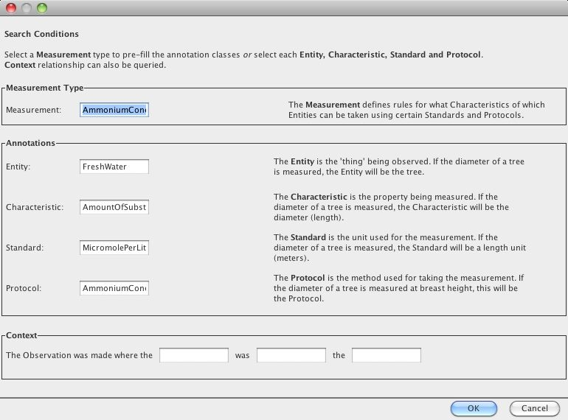

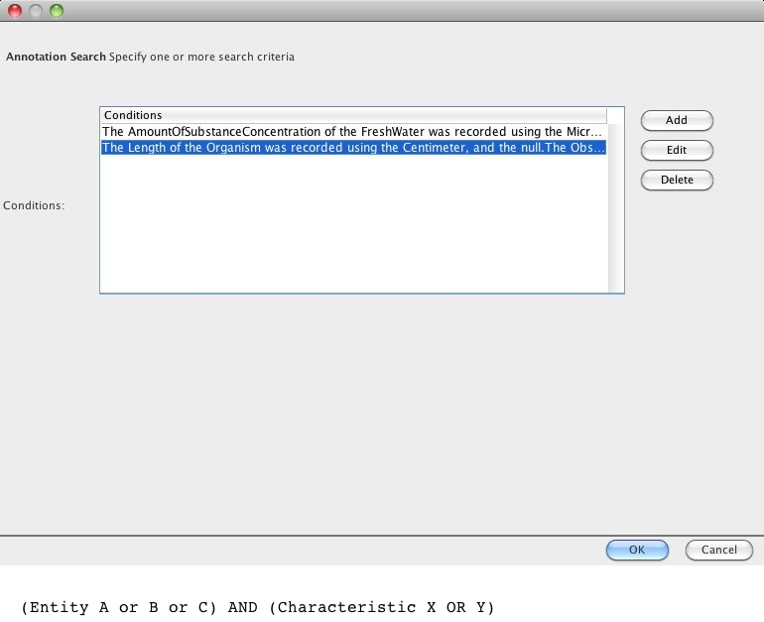

2. Discuss about itunes interface
It can be used to represent the semantic meaning as follows.

Any
All
Entity is Vertebrate
Entity is not Amphibian
Characteristic is Length
All
Entity is Vertebrate
Entity is not Mammal
Characteristic is SkullWidth
All
Measurement is AmmoniumConcentration

(HP Note: Mammal is a subclass of Vertebrate)

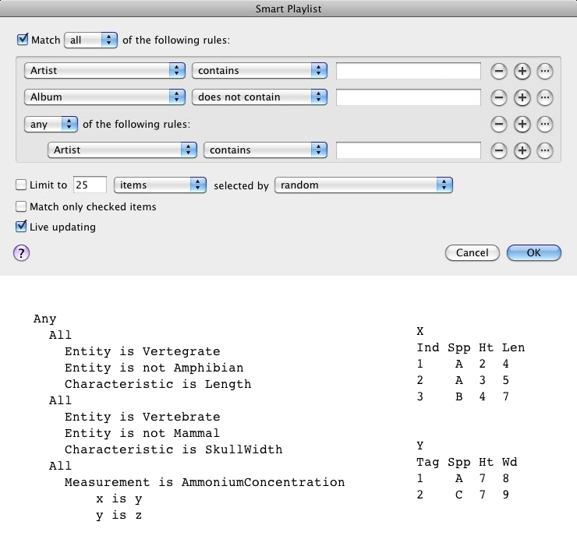
3. Language:

SPARQL query
Annotation a reference between datasets and ontologies

4. Search
E.g., return me the datasets which measure the height of the kelp is measured.
Ben's results are lists of datasets.
Huiping's results will be only the accurate results (with rows and the
height measurements only).

E.g., the following two datasets (by Matt)
X
Ind Spp Ht Len
1 A 2 4
2 A 3 5
3 B 4 7

Y
Tag Spp Ht Wd
1 A 7 8
2 C 7 9

The query can be like:
Show me all the dataset which measures the height (Ht) for entity A.
Ben will return X and Y as results.
Huiping will return the first two rows in X and the first row in Y.

Summarize:
Huiping's results are more accurate in a finer granularity.

4. Use case (Margaret)

